Assignment no :4

Title : To identify analysis classes and assign responsibilities ,prepare data dictionary. To draw analysis class model using UML 2.0 notation and implement class diagram with Java

Objective :
1.To study Analysis of classes and how to assign responsiblities.
2.To understand analysis class model and UML 2.0 notation.

Theory:-
Classes and Responsibility
Classes
A class is an element that defines the attributes and behaviors that an object is able to generate. The behavior is described by the possible messages the class is able to understand, along with operations that are appropriate for each message. Classes may also have definitions of constraints, tagged values and stereotypes.

Responsibilities
After identifying a set of core classes, we can now find the responsibilities in each class.
First, we have to identify the types of responsibilities are we looking for in each class:
- Behavior
Describes how a class does things that meet the requirements of the system.
- Knowledge
Describes the way in which a class will function by supplying information about itself.
An example that illustrate the two types of responsibilities are shown in the CRC card below.
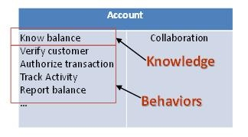

Class Notation
Classes are represented by rectangles which show the name of the class and optionally the name of the operations and attributes. Compartments are used to divide the class name, attributes And operation.
In the diagram below the class contains the class name in the topmost compartment, the next compartment details the attributes, with the "center" attribute showing initial values. The final compartment shows the operations setWidth, setLength and setPosition and their parameters. The notation that precedes the attribute, or operation name, indicates the visibility of the element: if the + symbol is used, the attribute, or operation, has a public level of visibility; if a - symbol is used, the attribute, or operation, is private.
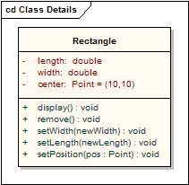

Interfaces
An interface is a specification of behavior that implementers agree to meet; it is a contract. By realizing an interface, classes are guaranteed to support a required behavior, which allows the system to treat non-related elements in the same way – that is, through the common interface.
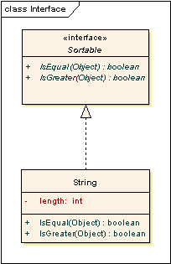

Associations
An association implies two model elements have a relationship - usually implemented as an instance variable in one class. This connector may include named roles at each end, cardinality, direction and constraints. Association is the general relationship type between elements. For more than two elements, a diamond representation toolbox element can be used as well. When code is generated for class diagrams, named association ends become instance variables in the target class. So, for the example below, "playsFor" will become an instance variable in the "Player" class.
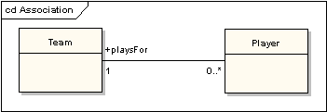

Generalizations
A generalization is used to indicate inheritance. Drawn from the specific classifier to a general classifier, the generalize implication is that the source inherits the target's characteristics. The following diagram shows a parent class generalizing a child class. Implicitly, an instantiated object of the Circle class will have attributes x_position, y_position and radius and a method display(). Note that the class "Shape" is abstract, shown by the name being italicized.
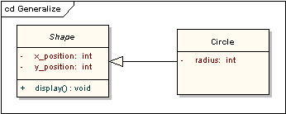

Aggregations:-
Aggregations are used to depict elements which are made up of smaller components. Aggregation relationships are shown by a white diamond-shaped arrowhead pointing towards the target or parent class.
A stronger form of aggregation - a composite aggregation - is shown by a black diamond-shaped arrowhead and is used where components can be included in a maximum of one composition at a time. If the parent of a composite aggregation is deleted, usually all of its parts are deleted with it; however a part can be individually removed from a composition without having to delete the entire composition. Compositions are transitive, asymmetric relationships and can be recursive.
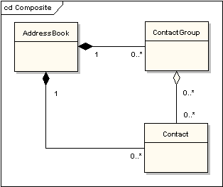

Association Classes
An association class is a construct that allows an association connection to have operations and attributes. The following example shows that there is more to allocating an employee to a project than making a simple association link between the two classes: the role the employee takes up on the project is a complex entity in its own right and contains detail that does not belong in the employee or project class. For example, an employee may be working on several projects at the same time and have different job titles and security levels on each.
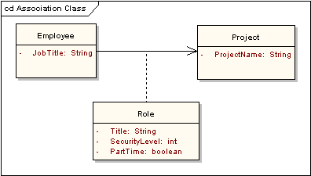

Dependencies
A dependency is used to model a wide range of dependent relationships between model elements. It would normally be used early in the design process where it is known that there is some kind of link between two elements, but it is too early to know exactly what the relationship is. Later in the design process, dependencies will be stereotyped (stereotypes available include «instantiate», «trace», «import», and others), or replaced with a more specific type of connector.

Traces
The trace relationship is a specialization of a dependency, linking model elements or sets of elements that represent the same idea across models. Traces are often used to track requirements and model changes.

Realizations
The source object implements or realizes the destination. Realizations are used to express traceability and completeness in the model - a business process or requirement is realized by one or more use cases, which are in turn realized by some classes, which in turn are realized by a component, etc.

Nestings
A nesting is connector that shows the source element is nested within the target element. The following diagram shows the definition of an inner class, although in EA it is more usual to show them by their position in the project view hierarchy.
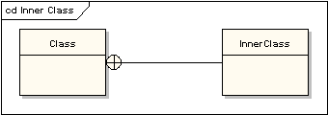

class diagram:-
The class diagram shows the building blocks of any object-orientated system. Class diagrams depict a static view of the model, or part of the model, describing what attributes and behavior it has rather than detailing the methods for achieving operations. Class diagrams are most useful in illustrating relationships between classes and interfaces. Generalizations, aggregations, and associations are all valuable in reflecting inheritance, composition or usage, and connections respectively.
Conclusion:

